# **ANNUAL EXAMINATION - 2077**

**Grade: V Full Marks: 50**

**Subject: Science Pass Marks: 20**

**Time: 1 hour and 30 minutes**

**Group A: Science [33 marks]**

* 1. **Answer the following questions. [10 * 2 = 20]**
     1. What are cold blooded vertebrates?
     2. Draw a neat picture of fish.
     3. Define cell.
     4. What is flower?
     5. Write two functions of leaf.
     6. What is solid matter? Give four examples.
     7. What are clouds? Write their types.
     8. What is *dhiki*? Write its main parts.
     9. Draw a neat picture of *janto*.
     10. Write short notes on *kol*.
  2. **Drawa neat picture of flower and label its main parts. [3]**
  3. **Write down two important features of following. [4 * 1 = 4]**
     1. Fish
     2. Frog
     3. Birds
     4. Bat
  4. **Label the given figure. [3]**

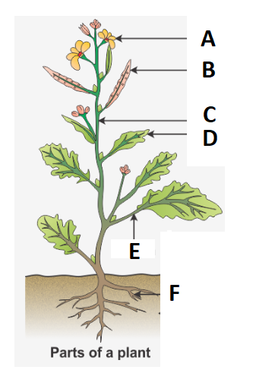

* 1. **What is stem? Write two functions of stem. [3]**

**Group B: Health Education [17 marks]**

1. **Answer the following questions. [7 * 2 = 14]**
   * 1. What is meant by environment sanitation?
     2. What are communicable diseases? Give four examples.
     3. Write any two methods of disposal of wastes.
     4. What is bleeding? How can we stop it?
     5. What is safety? What is first aid?
     6. List any two safety measures that we should follow while walking on the road?
     7. What is personal hygiene?
2. **Match the following. [6 * 0.5 = 3]**

Discomfort Reduce immunity

AIDS Non communicable

Diabetes Mycobacterium tuberculosis

TB Disease

Whooping cough DPT

Measles Paramyxo virus

*Best Wishes!!!*